**J026**

**SAMEER MULANI**

**BTECH DS**

**AAD ASSIGNMENT 3**

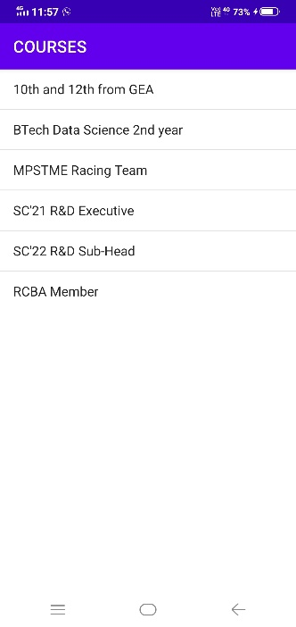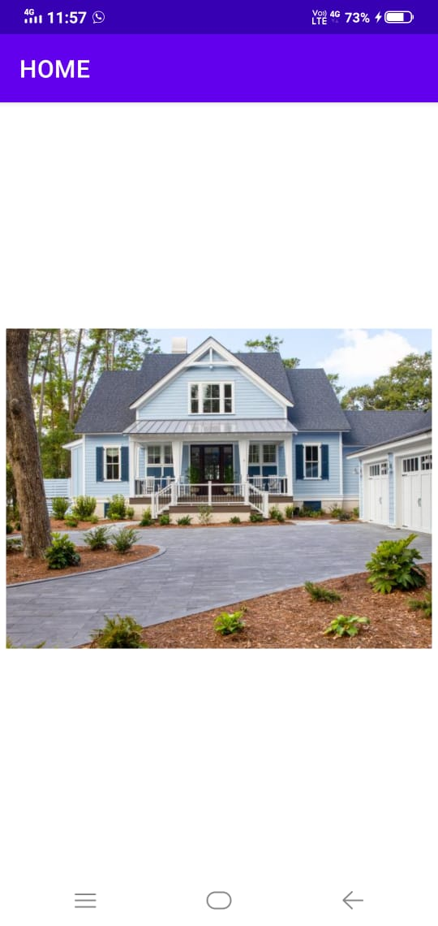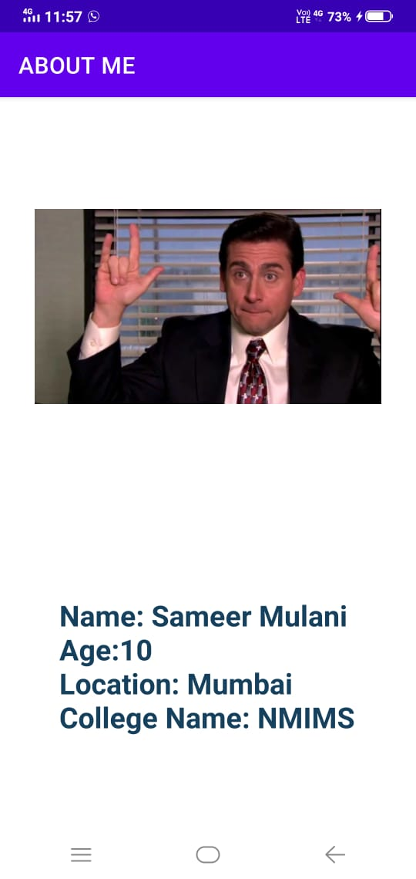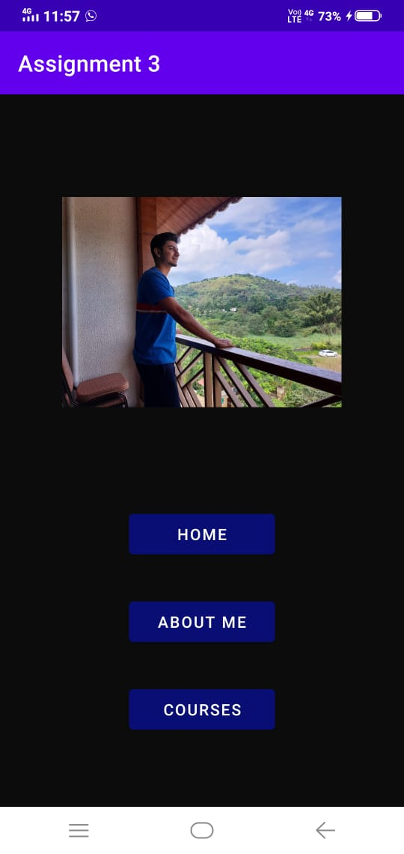

**MainActivity.java**

Button hmbtn;  
Button abtbtn;  
Button courbtn;  
hmbtn = findViewById(R.id.*hmbtn*);  
abtbtn = findViewById(R.id.*abtbtn*);  
courbtn = findViewById(R.id.*courbtn*);  
  
Intent ihome;  
ihome = new Intent(MainActivity.this,Home.class);  
  
Intent iAbt;  
iAbt = new Intent(MainActivity.this,About.class);  
iAbt.putExtra("name","Sameer Mulani");  
iAbt.putExtra("Age",19);  
iAbt.putExtra("location","Mumbai");  
iAbt.putExtra("college","NMIMS");  
  
Intent iCourses;  
iCourses = new Intent(MainActivity.this,Courses.class);  
  
hmbtn.setOnClickListener(new View.OnClickListener() {  
 @Override  
 public void onClick(View view) {  
 startActivity(ihome);  
 }  
});  
abtbtn.setOnClickListener(new View.OnClickListener() {  
 @Override  
 public void onClick(View view) {  
 startActivity(iAbt);  
 }  
});  
courbtn.setOnClickListener(new View.OnClickListener() {  
 @Override  
 public void onClick(View view) {  
 startActivity(iCourses);  
 }  
});

**About.java**

TextView abtview;  
abtview = findViewById(R.id.*abtview*);  
  
Intent fromAct = getIntent();  
String name = fromAct.getStringExtra("name");  
int age = fromAct.getIntExtra("age",10);  
String location = fromAct.getStringExtra("location");  
String college = fromAct.getStringExtra("college");  
  
abtview.setText("Name: "+name + "\nAge:" + age + "\nLocation: " + location + "\nCollege Name: "+ college);  
getSupportActionBar().setTitle("ABOUT ME");

**Courses.java**

getSupportActionBar().setTitle("COURSES");  
ListView list;  
list = findViewById(R.id.*list*);  
  
ArrayList<String> courses = new ArrayList<>();  
courses.add("10th and 12th from GEA");  
courses.add("BTech Data Science 2nd year");  
courses.add("MPSTME Racing Team");  
courses.add("SC'21 R&D Executive");  
courses.add("SC'22 R&D Sub-Head");  
courses.add("RCBA Member");  
  
ArrayAdapter<String> adap = new ArrayAdapter<>(getApplicationContext(), android.R.layout.*simple_list_item_1*,courses);  
list.setAdapter(adap);

**Activity_main xml**

<ImageView  
 android:layout_width="249dp"  
 android:layout_height="245dp"  
 android:layout_marginBottom="60sp"  
 android:src="@drawable/sameer" />  
  
<Button  
 android:id="@+id/hmbtn"  
 android:layout_width="130dp"  
 android:layout_height="wrap_content"  
 android:layout_marginBottom="30sp"  
 android:backgroundTint="#090E75"  
 android:text="Home" />  
  
<Button  
 android:layout_width="130dp"  
 android:layout_height="wrap_content"  
 android:text="About me"  
 android:layout_marginBottom="30sp"  
 android:backgroundTint="#090E75"  
 android:id="@+id/abtbtn" />  
<Button  
 android:layout_width="130dp"  
 android:layout_height="wrap_content"  
 android:text="Courses"  
 android:backgroundTint="#090E75"  
 android:id="@+id/courbtn"/>

**Activity_about xml**

<ImageView  
 android:layout_width="300dp"  
 android:layout_height="200dp"  
 android:src="@drawable/mic"  
 android:layout_marginBottom="150sp"/>  
  
<TextView  
 android:layout_width="wrap_content"  
 android:layout_height="wrap_content"  
 android:text="Sameer"  
 android:textStyle="bold"  
 android:textColor="#15415E"  
 android:textSize="25sp"  
 android:id="@+id/abtview"  
 />